**CIT 352 Chapter 5**

Name: Celeste George

Complete all Projects by executing every step in each project.  For those steps listed below, follow the specified instruction.

Project 5-1

Step 7

* Insert the screen capture

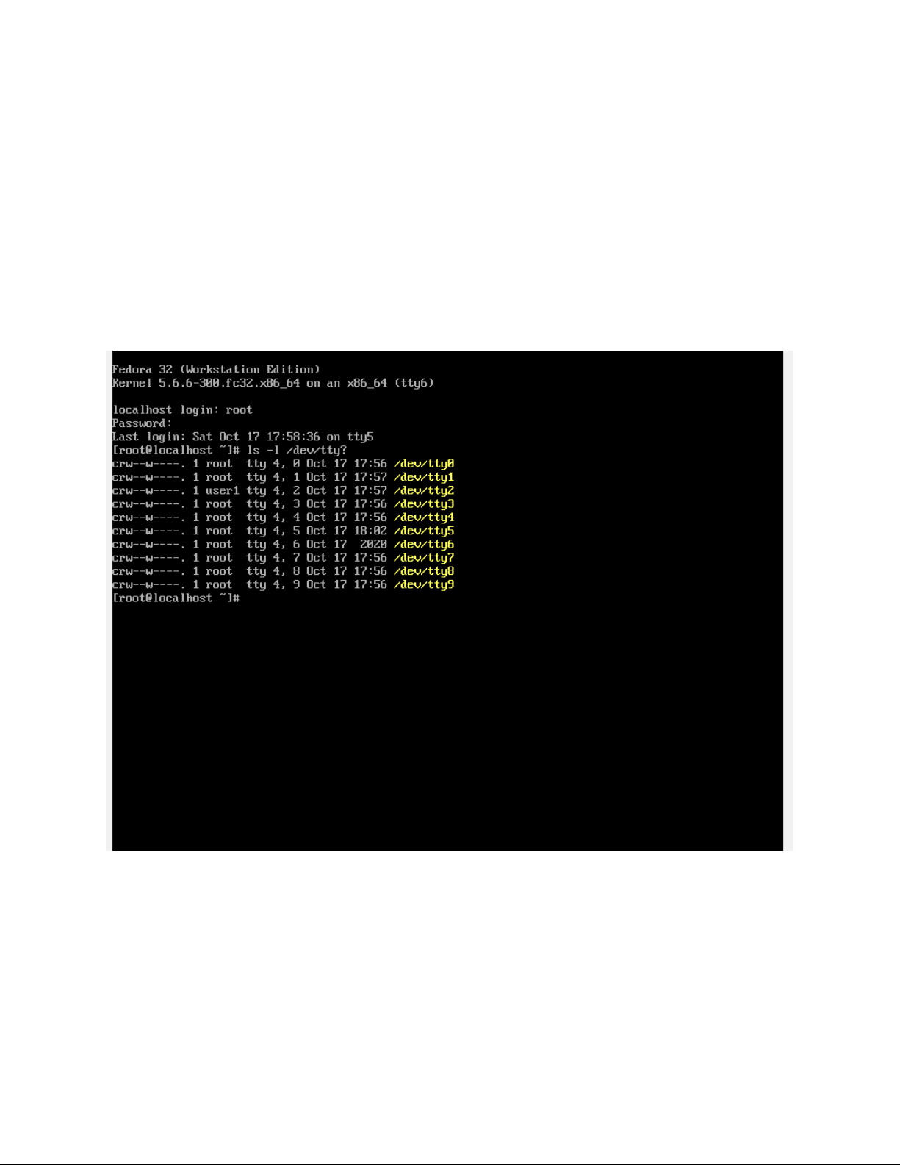

Project 5-2

Step 9

* Insert the screen capture

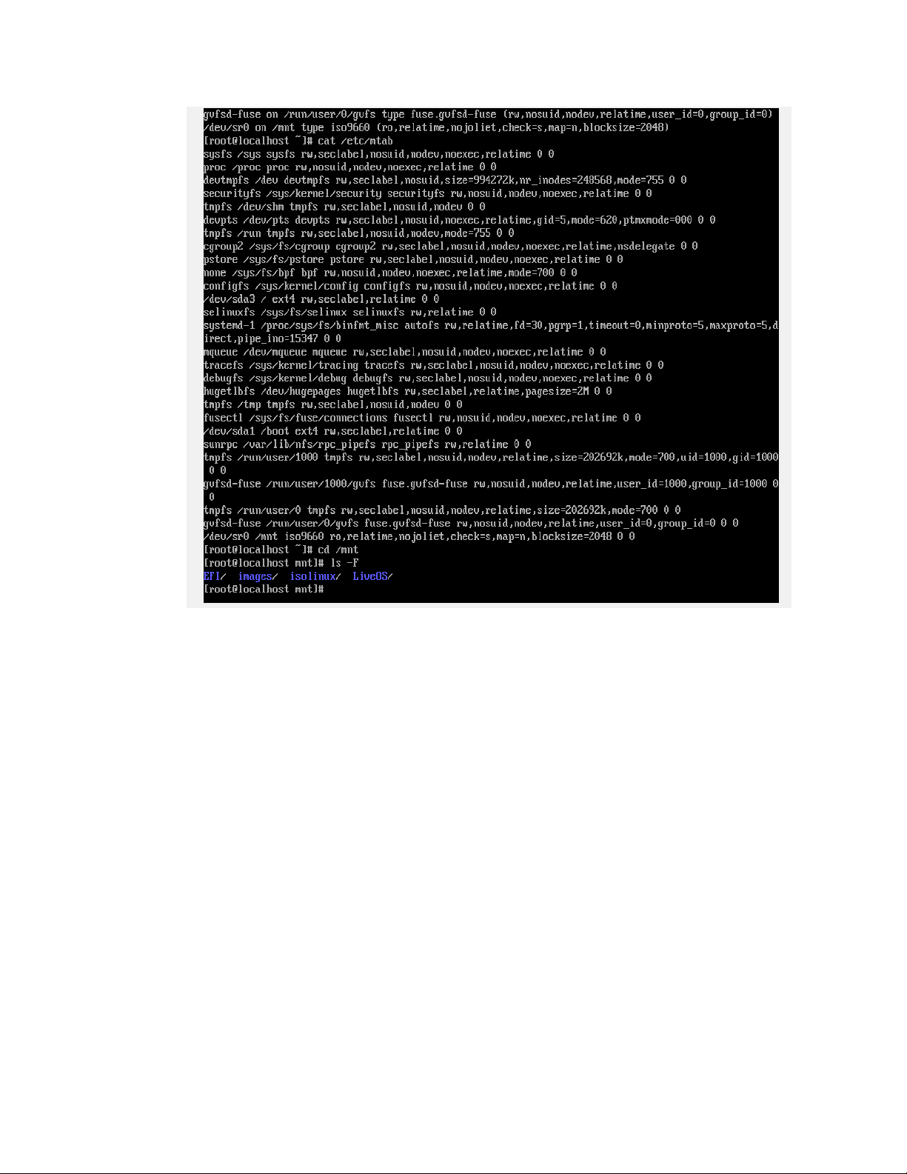

Errata: [original] [Updated]

du -hT df -hT for every occurrence

Project 5-3

Step 8

* Insert the screen capture

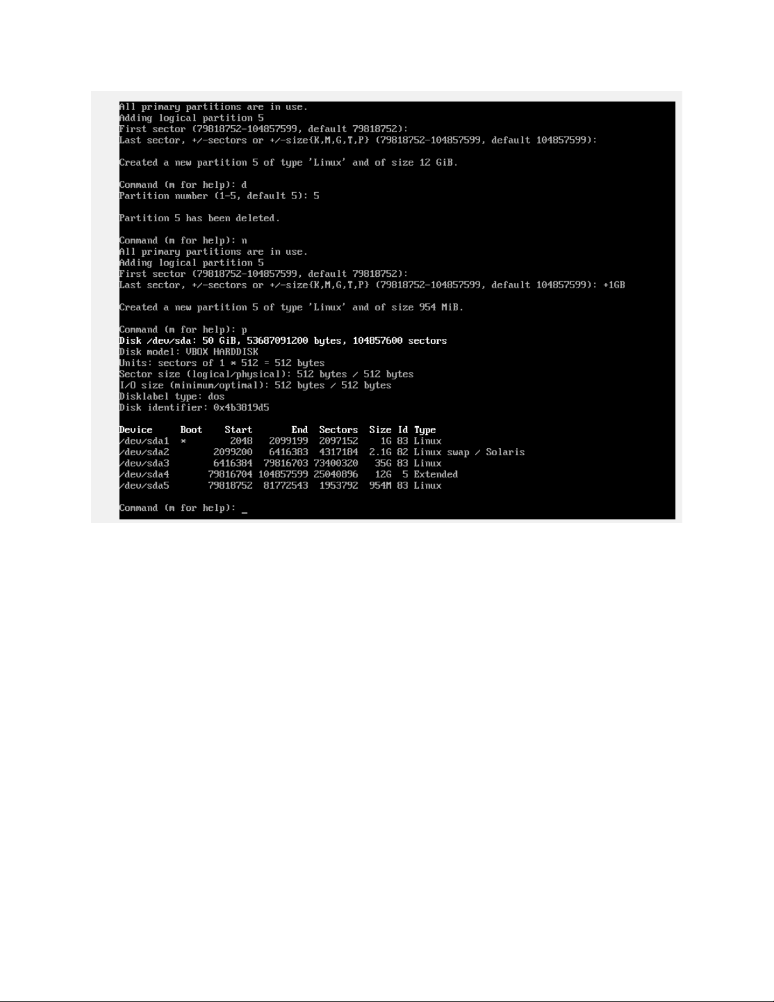

Step 14

* Insert the screen capture

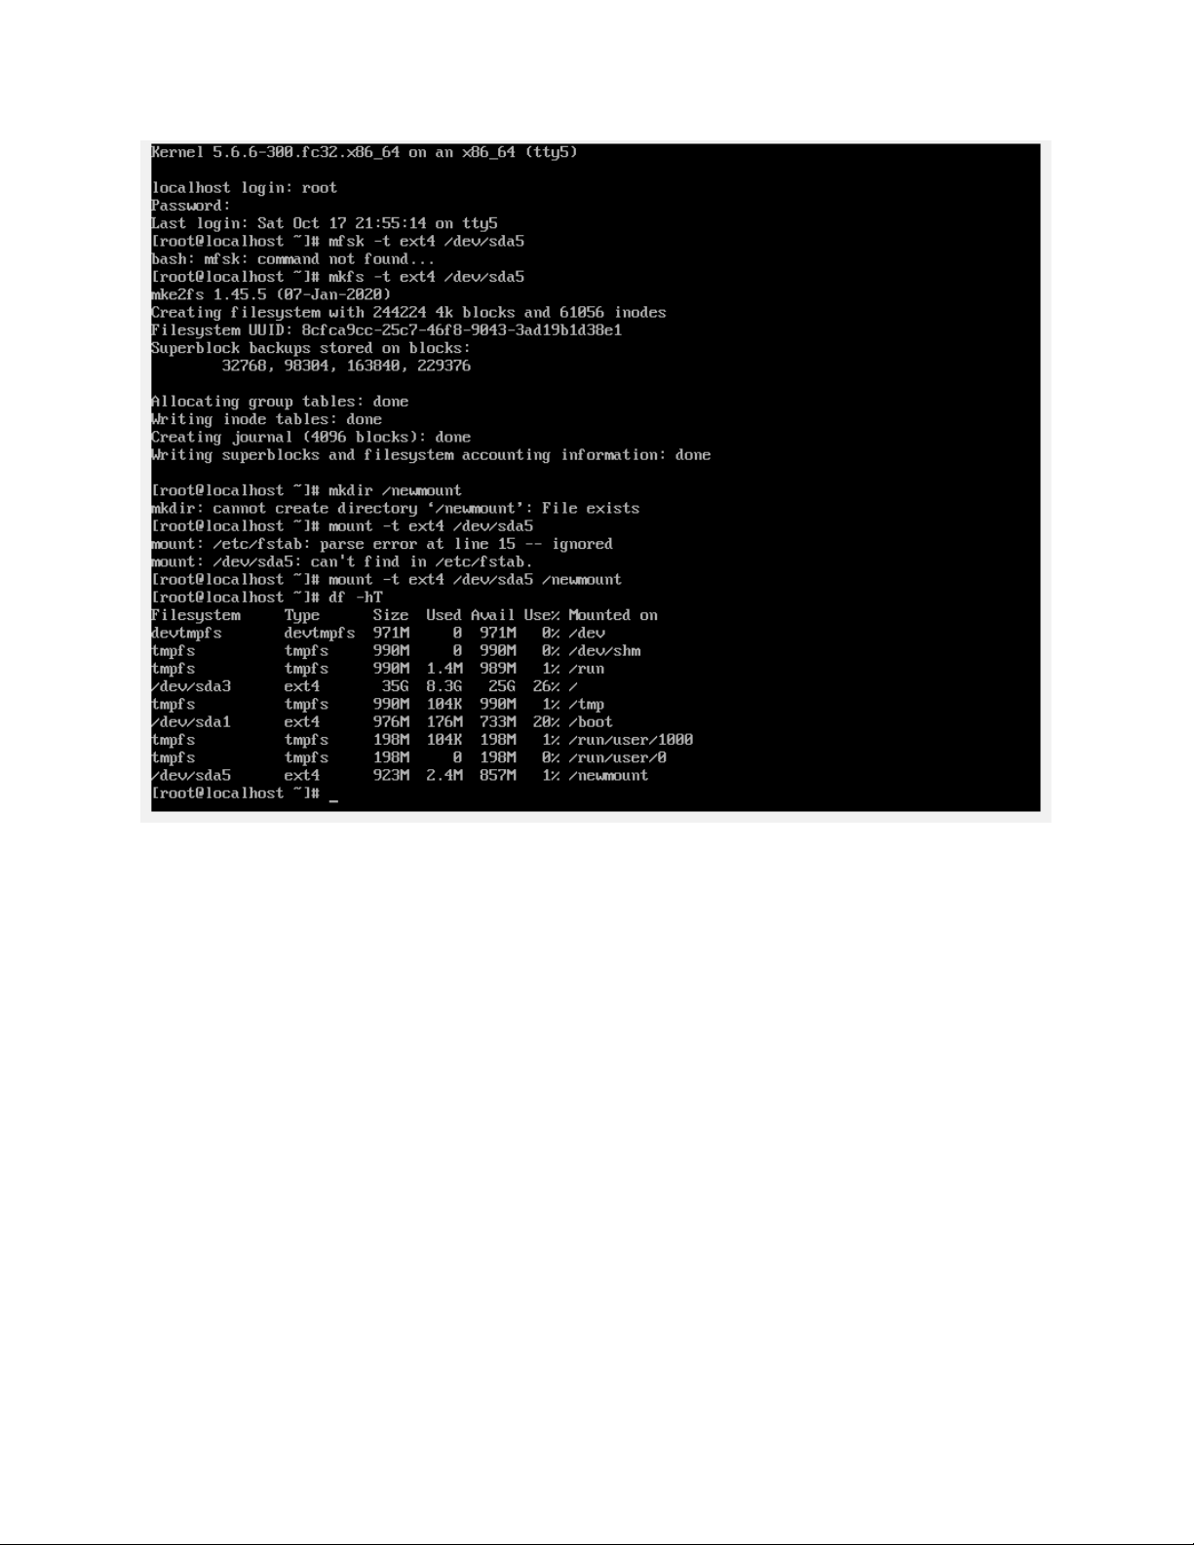

Project 5-4

Step 5

* Insert the screen capture

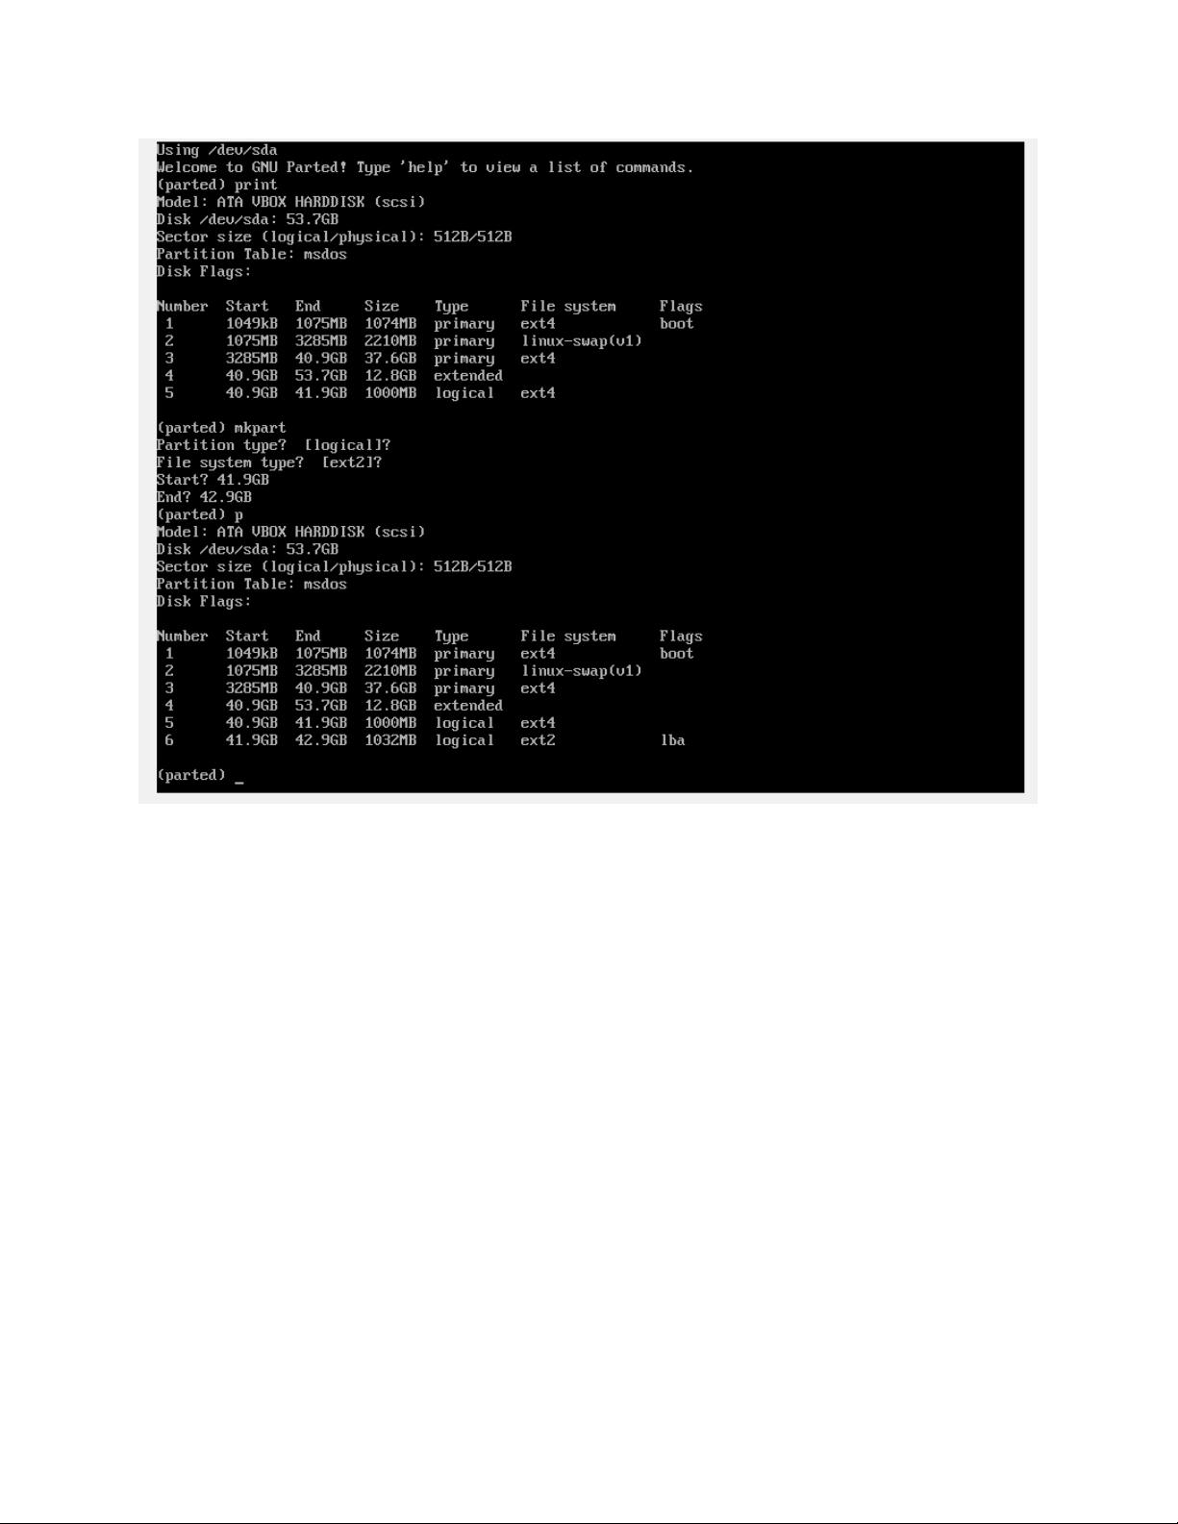

Step 13

* Insert the screen capture

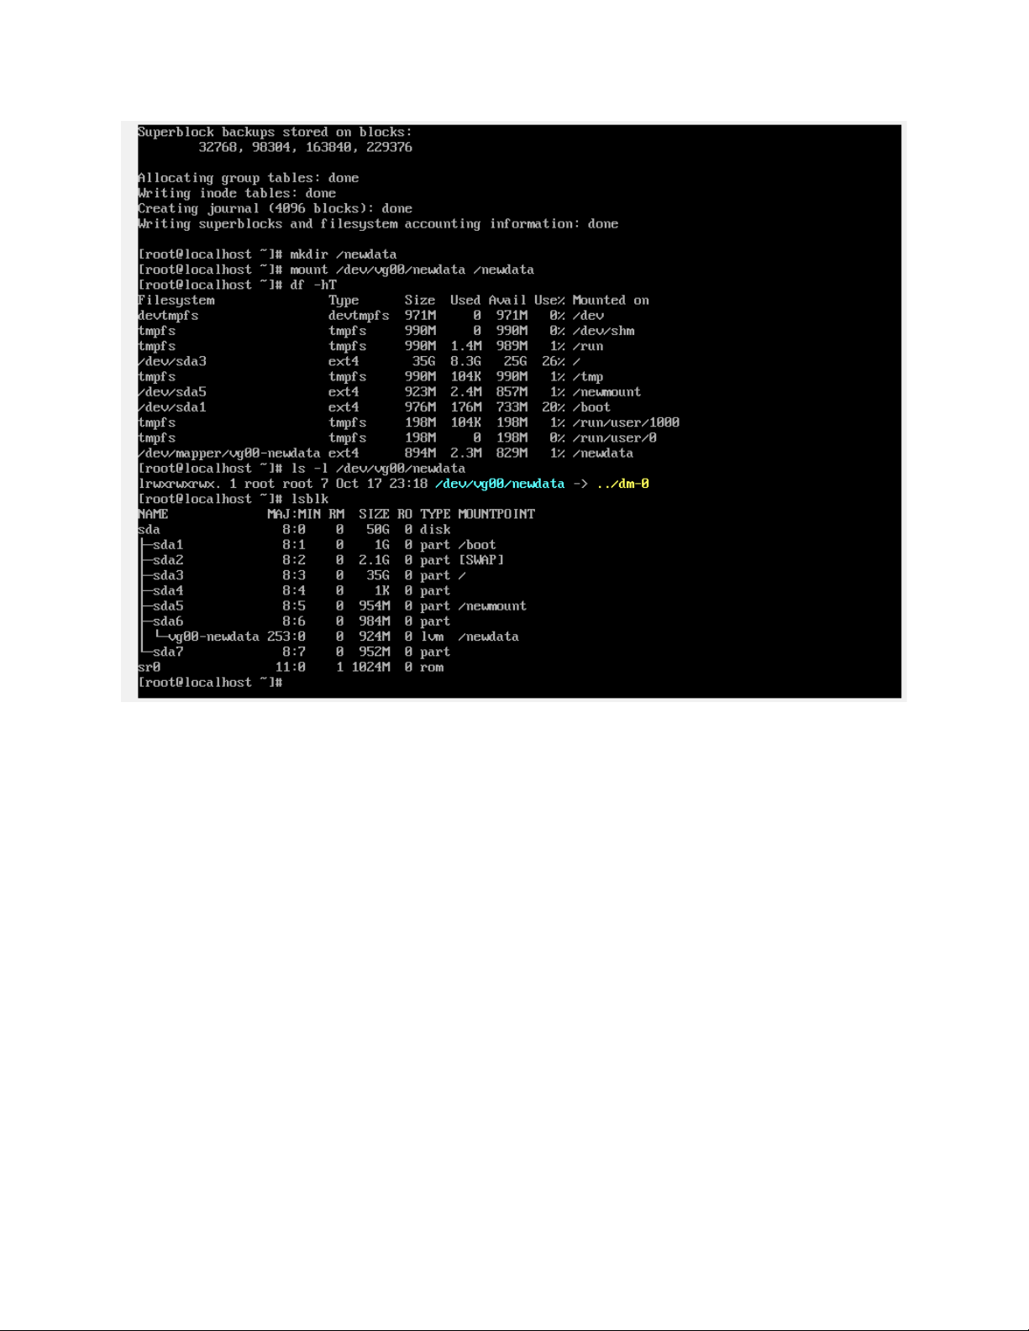

Step 18

* Insert the screen capture

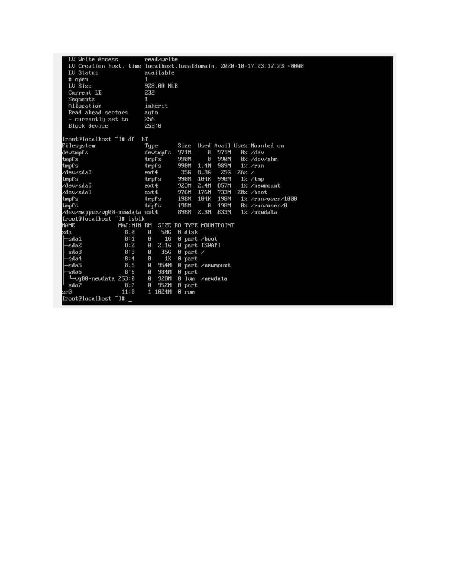

Project 5-5

Step 6

* Insert the screen capture

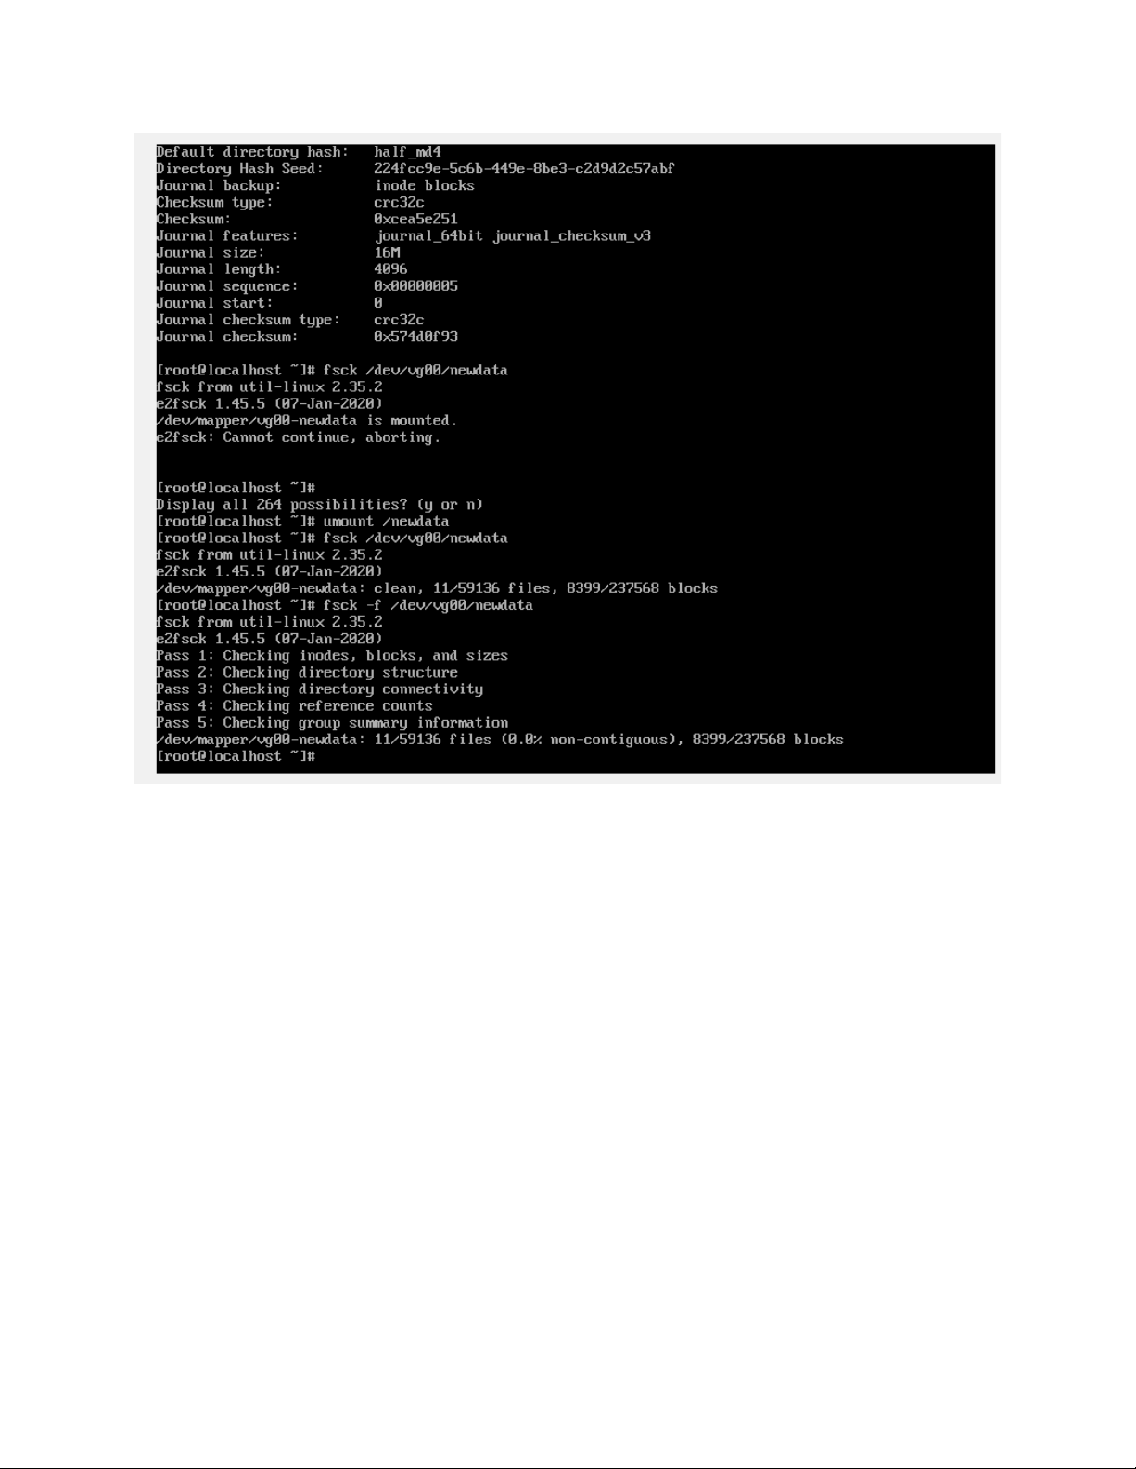

Project 5-6

Step 12

* How many files and directories can user1 create on this partition?

Answer 1

* How much space can user1 use in total on this partition?

Answer 1

Step 16

* How many files has user1 stored on this volume so far?

Answer 1

* What is the full path of this file?

300 to 400

* What is the total size of those files (in 1 KB blocks) and why?

Answer 1

* Insert the screen capture

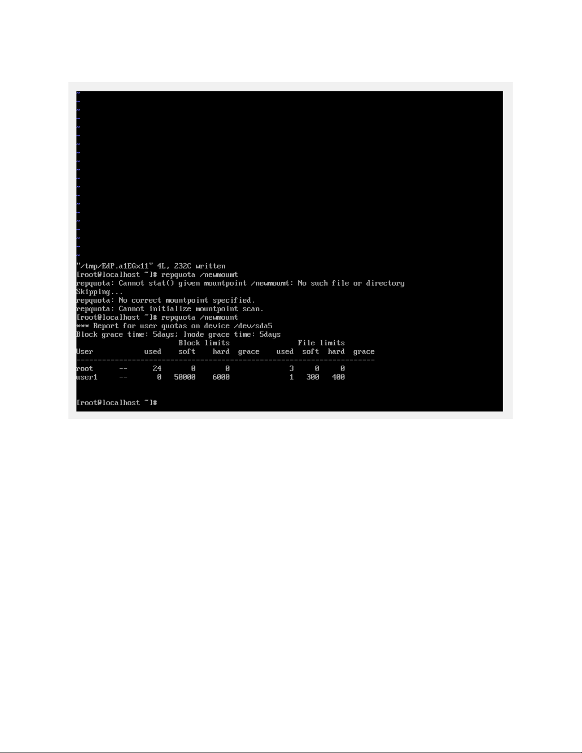

Project 5-7

Step 12

* Insert the screen capture

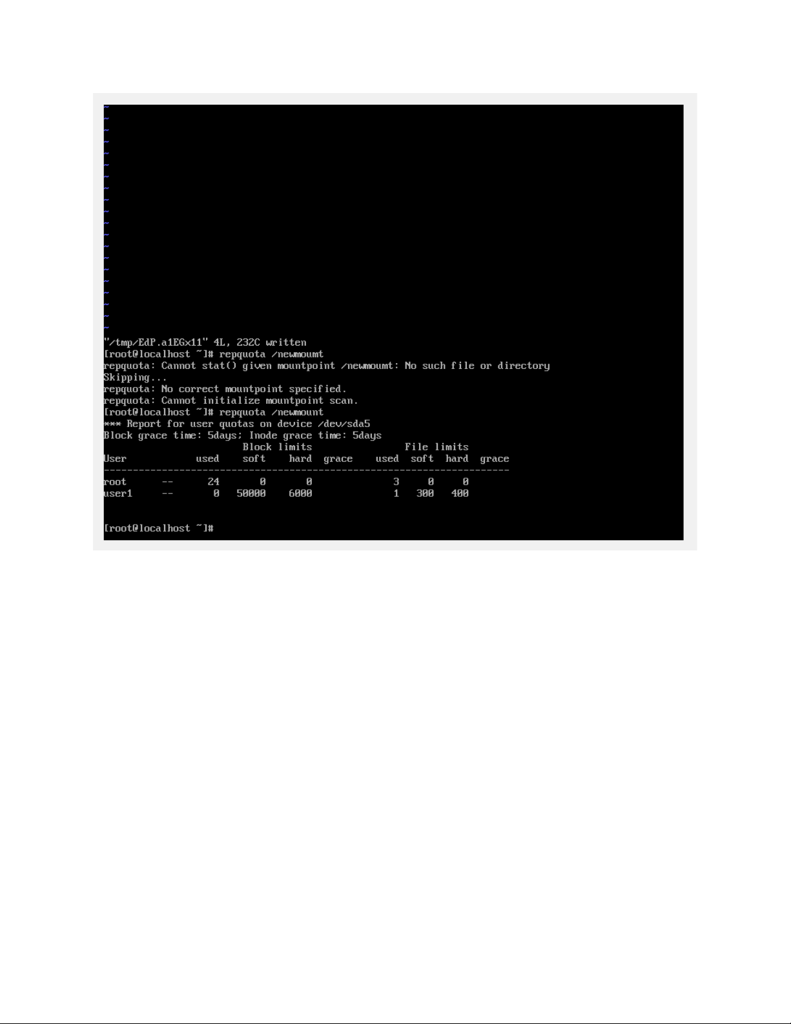

**Command Reference** (List all new commands you learned in this chapter)

Lsblk

Fdisk

Mkfs

Pvcreate

Pvscan

Vgcreate

Vgscan

Vgdisplay

Lvcreate

Lvdisplay

**Discovery Exercises**

Solve the following problems from the textbook under Discovery Exercises. Search the Internet for answers if you don’t know.

2.

a. At the completion of the exercise, insert the screen capture of the output of lvdisplay command which shows that LV Size is about 5.7 GB

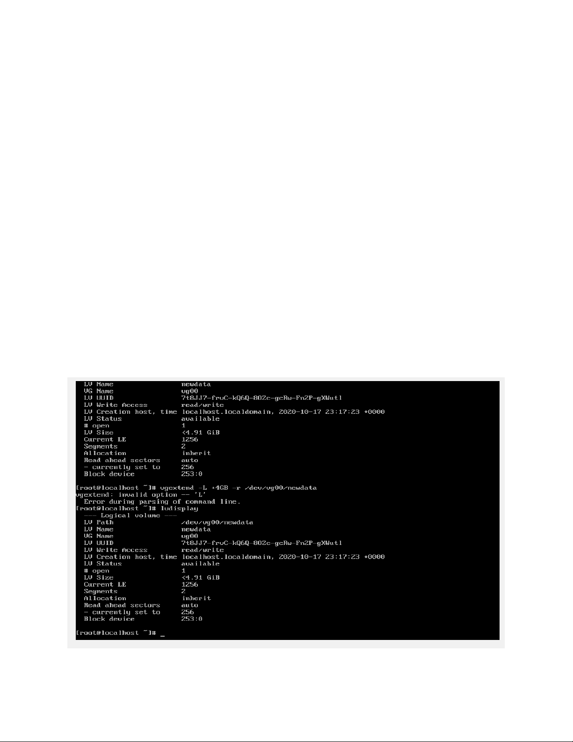

b. Skip (No need to do 2b)

Here are the steps to add 8 GB of storage space.























